- Challenge Name and Category: The Numbers (Cryptography)
- Difficulty/Points: Easy.
- Description: The numbers... what do they mean? numbers.png
- Flag: picoCTF{THENUMBERSMASON}
- Solution/Walkthrough: There are several A1Z26 decoders available on the internet. The Letter-to-Number Cipher (or Number-to-Letter Cipher or numbered alphabet) consists in replacing each letter by its position in the alphabet, for example A=1, B=2, Z=26, hence its over name A1Z26. To decipher the flag, I copied it and pasted it into the tool. After it was decrypted, I simply had to place the curly brackets in the correct locations.
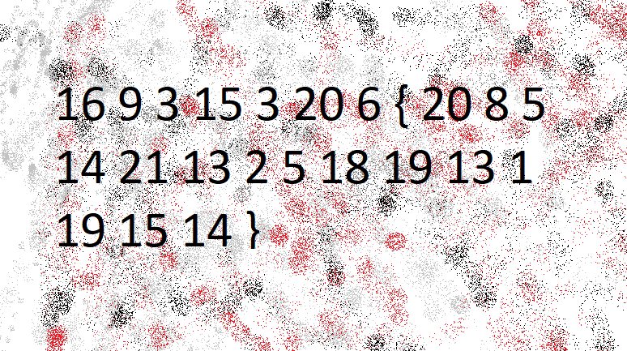
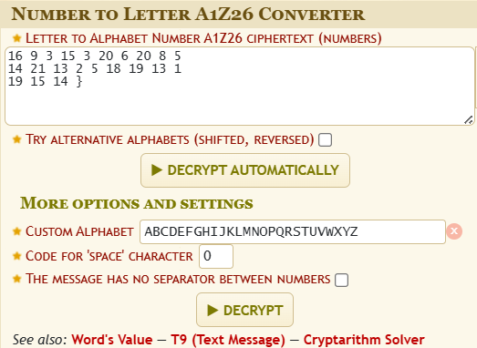
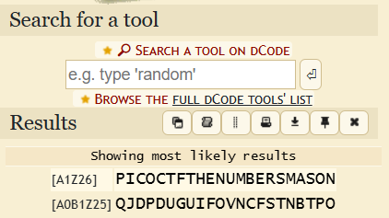
- Tools Used: https://www.dcode.fr/letter-number-cipher
- Hypothesis Formulation: Based on the_numbers.png information I could see curly brackets. I assumed I was looking at the flag in an encrypted state.
- What Worked vs. What Didn't: At first, I thought it was hex. Afterwards I tried to figure out what cipher was used.

